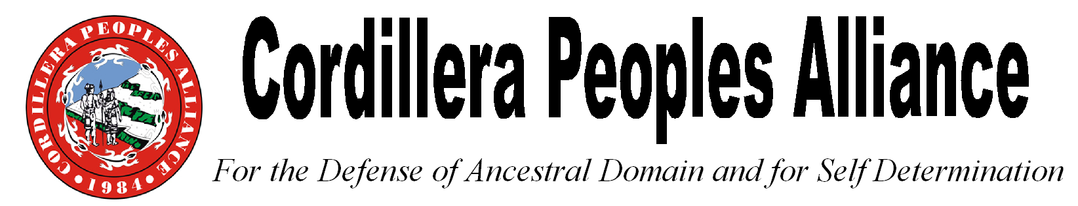
No. 55 Ferguson Road, 2600 Baguio City, Philippines
Tel. No. (63)74 4229754, Fax No. (63)74 4437159, Website: www.cpaphils.org
Press Release
October 21, 2016

Cordillera Peoples Alliance condemns AFP and police violence during Lakbayan

The Cordillera Peoples Alliance (CPA) strongly condemns the violent dispersal of the peaceful protest of around 1,000 IP and Moro, including Igorots, in front of the US Embassy on October 19, 2016, and demands the accountability of the US Embassy and Philippine National Police (PNP). The protesters were delegates of the Lakbayan ng Pambansang Minorya para sa Sariling Pagpapasya at Makatarungang Kapayapaan (Journey of National Minorities for Self Determination and Just Peace). The violent dispersal resulted in injuries to more than 50 people. The protesters were blasted with water canons and tear gas, and were brutally run over by a police mobile. A day before the incident, the same group was violently dispersed in their protest action in front of the headquarters of the Armed Forces of the Philippines (AFP) on October 18.
During the indignation rally held inside the University of the Philippines Diliman campus on October 20, Windel Bolinget, Cordillera Peoples Alliance (CPA) Chairperson, expressed that “We are protesting against the numerous human rights violations by the AFP and PNP, and the plunder of our ancestral lands and resources by the State and foreign corporations. We are fighting for our right to self determination, to freely decide our own course of political, economic and cultural development as IPs. We are also pushing for an independent foreign policy as we seek an end to US control of the Philippines. We came to Manila to demand justice for the political killings, enforced disappearance, harassment and various forms of human rights violations that are committed especially by the AFP in our communities. We came to seek government action on the destruction and plunder of our ancestral lands and resources. But on October 18-19, we were met with violence by the AFP and PNP.”
“The inhumane treatment to the Igorots, fellow indigenous peoples (IPs) in other regions of the country and the Moro people by State security forces as seen in the violent dispersals shows the continued discrimination and oppression of IPs and Moro. No one deserves to be run over by a police car. No one deserves to be killed for defending our lands and resources, human rights and our rights as indigenous peoples. No one deserves to be killed for being an indigenous person or Moro, and for holding a protest in front of an Embassy of the United States,” added Bolinget.
Among those injured when the police mobile run over the protesters was Pya Malayao, an Igorot from Bontoc, Mountain Province who is also the Secretary General of Katribu Kalipunan ng mga Katutubong Mamamayan ng Pilipinas and a convenor of the Sandugo Movement of Moro and Indigenous Peoples for Self Determination.
“We call for the imprisonment of Police Officer 3 Franklin Co, the driver of the police mobile that rammed over our delegates, and Police Senior Superintendent Marcelino Pedroso, head of Western Police District who commanded the police violence, and for them to be permanently relieved from their posts. In 2004, Pedroso was suspended from his police job for committing kidnapping and extortion but was reinstated in 2005. He deserves to be put in jail as soon as possible. Justice to the victims of the violent dispersals will not be achieved until all those accountable answer for their crimes,” added Bolinget.
Despite the indefinite unilateral ceasefire declared by the Duterte administration, military troops continue to encamp in Lubuagan, Kalinga and harass and intimidate indigenous women and community leaders. During the Lakbayan ng Pambansang Minorya and the protest actions held on October 18-19, the CPA called for the pull out of AFP troops in Lubuagan, Kalinga and other Cordillera communities. It also reiterated its call for the Lepanto mining operations to stop, and for the US-owned Chevron company and SN Aboitiz to withdraw their geothermal and energy projects in the Cordillera.
Bolinget also stressed that the CPA calls for the total withdrawal of the US from the Philippines as a step forward in developing the country’s independent foreign policy and developing our own national industries.
Organized by various IP and Moro organizations, including the Cordillera Peoples Alliance, the Lakbayan ng Pambansang Minorya is a show of solidarity and united action of IPs and Moro. Series of educational fora, various engagements and protest actions were held from October 13-21, 2016 in the National Capital Region. 250 IPs from all provinces of the Cordillera were part of the 3,000 IPs and Moro delegates of the Lakbayan.***
Reference: Windel Bolinget, CPA Chairperson

